**Livres pour le réseau sur le sapin de Noël- Anglais**

*Maple & Willow’s christmas tree*, Lori Nichols, Nancy Paulsen Books, 2016

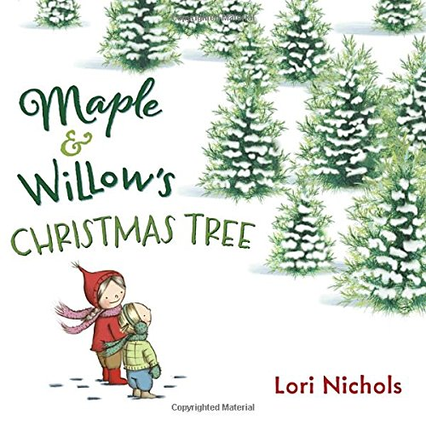

Maple and Willow *love* trees—and now they are getting their first real Christmas tree. It is going to be the *best* Christmas ever! After a snowy expedition to pick out the perfect tree, it’s time to decorate. But whenever Maple gets near the tree, she starts sniffling and sneezing. Could she really be allergic to the perfect Christmas tree? And if so, how will the girls find a way to make this the best Christmas after all?

*Pick a pine tree*, Paticia Toht & Jarvis, Candlewick Press, 2017


                            PICK A PINE TREE by Patricia Toht

A family of four buys a cut pine tree, takes it home, and, with the help of friends, decorates it for their Christmas tree.

The family drives to a tree lot, selects a tree, and takes it home on top of their car. The mother, the father, and their two children set up the tree, with the mother using a saw to trim the tree trunk. Boxes of decorations are brought in, and then friends arrive for a decorating party. When all the decorations are in place, the page turn reveals the completed tree in all its glory. That illustration is printed in landscape format across the double-page spread, so the book must be rotated 90 degrees to emphasize the tree’s height, a clever and surprising feature. The family’s interracial, with a white dad and black-haired, brown-skinned mom. Other characters at the tree lot and the party include people of different ethnicities. The short, rhyming text has a bouncy, appealing tone, with four brief lines of text per page. Delightful mixed-media illustrations use a flattened perspective, simple shapes, and glowing, light-filled backgrounds for a fresh take on the tree-decorating tradition. The illustrations are all in double-page-spread format with compositions that will work well for reading to a group or with just one child in a lap.